BIT607 Web Development

Student

Wesley De Beer

Student No.

5047946

Date: 12/09/2022

# Part 1 : Application

This part has been uploaded as a zip file with this document.

# Part 2 : Report

Question G

The security issues that were identified and were taken into consideration for this design were the top ten of the OWASP website. The first security issue was “Broken Access Control”. This is when a user can act outside of their permissions. They can bypass the security of the website by either altering the information or altering the URL. To prevent these kinds of attacks as per the OWASP website, the attacker should not be able to modify any access or control check or any metadata. With our website, all data is public except for the staff portal. This will be secured behind a login and access to this will only be granted to certain users.

The next consideration we took was that of “Vulnerable and outdated Components”. This is mainly when you are using outdated versions of software or extensions on your website. When you are using outdated software you can open yourself up to certain attacks. There needs to be a system in place to make sure that you are regularly scanning and updating your software when required. The latest security patches can prevent certain attacks.

The next security risk I identified is Ddos attacks. These can be prevented by using a CDN, a content delivery network, that can be set up with places like Cloudflare. What this does is that when are user accesses the website it gets the content from the server that is closest to it. So if the website is accessed from a country such as the USA the server in the USA delivers the content.

Question H

What are HTTP caching and content delivery? Caching works by storing commonly used files so that they can be accessed quicker and more easily. This can improve the delivery of content and therefore speed up your website’s performance. Content delivery networks work by storing certain content of the website that is not likely to change over time or from user to user. These can be your normal static files such as images, videos, music, etc. These can be stored on CDN and therefore can load quicker than if they are downloaded from a server that might be sitting in a different country. By accessing this network you are cutting down on the bandwidth needed to deliver the content. This will also improve the user's experience and will also ensure reliability for the delivery of your content.

Question I

The first responsive design principle that we focused on the most was the size of the screen the user had. We did this as the owners used their mobile devices the most. What we did is that depending on the size of the screen it will display the content in different positions. Also, the main picture of the restaurant will change to load a new picture if the screen size is smaller than 600px.

We also used what is called “Content-based breakpoints” This is where we have designed the content to be presented in a certain way rather than relying on the device to manage this itself. This can be found in the menu pages and also the privacy pages.

We have also chosen a design that is more efficient to be loaded on mobile devices as this was the most commonly used method for accessing this website. We aimed to keep the loading times down.

All our pages have been designed using relative units. We have used percentages where possible and do not use the px for the width or height of items that need to be displayed. This will allow the items to resize depending on the device that is being used.

Question J

The first extension used is called “ One Dark Pro”. The main reason that I use this extension is for the visual aid that it provides. This can make coding better or simpler when everything is colour coded. Some people say that dark themes are better for your eyes as they provide less stress and strain on them.

The other extension that I have used is the Edge tools for VS code. This tool allows you to open a browser window inside your vs code. This made things easier for me as I did not have to keep moving between VS and a browser. It allowed me to easily test out CSS styles before adding them to my sheet.

Question K

For the performance of the site, we used the Google Chrome F12 developers tools. These tools were also used throughout the design of the website as well. It was used for CSS style changes and also to identify some problem areas that would need fixing along the way. The console was used to highlight some issues that could come up with compatibility and also some issues we might have with the performance. We used this tool to be able to change the download speed to simulate a mobile phone, or a poor connection to see how the website will respond in this situation. This was used through the Network tab and through setting the performance to be 3G with throttling.

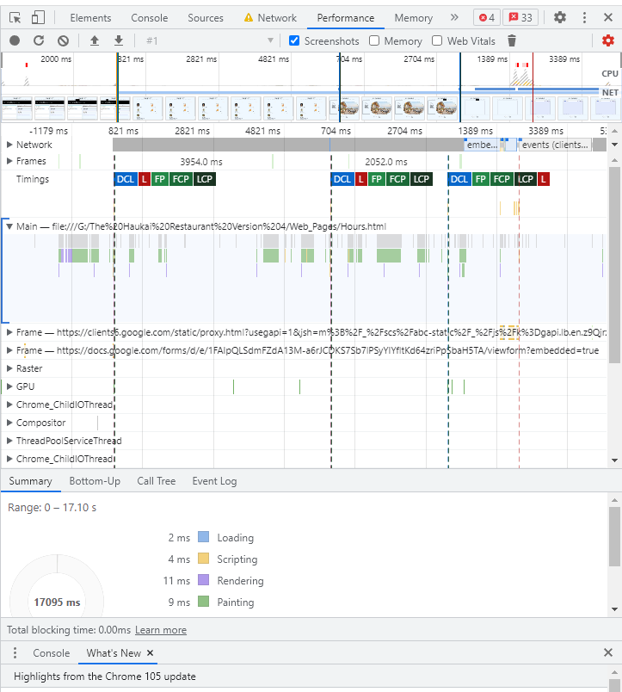

References

W3Schools : HTML turorial and online web references :

<https://www.w3schools.com/>

OWASP : The top 10 security issues with websites, 2022 :

<https://owasp.org/>